SPEED AND DENSITY
Pearson Edexcel – Sample Papers - Paper 2 (Calculator) Foundation Tier

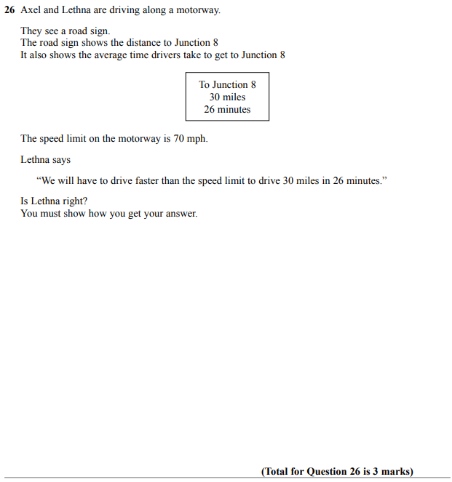

OCR Thursday 25 May 2017 – Morning (Calculator) Foundation Tier

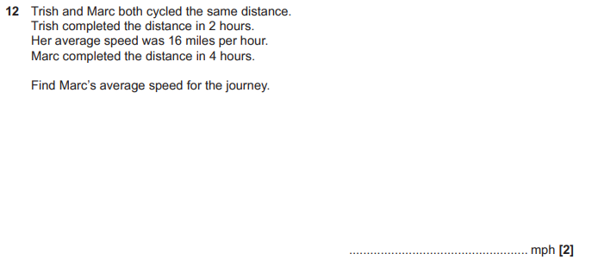
OCR Sample Question Paper 1 – Morning/Afternoon (Calculator) Foundation Tier

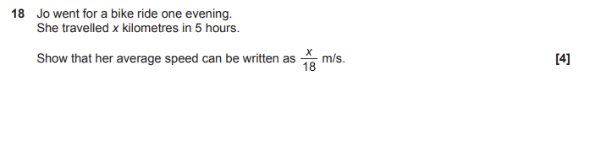

OCR Sample Question Paper 3 – Morning/Afternoon (Calculator) Foundation Tier

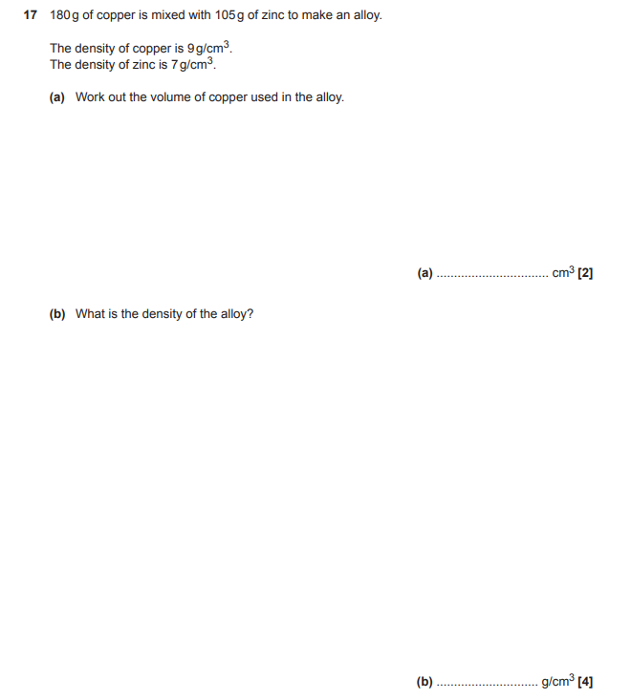

AQA Thursday 4 June 2020 – Morning (Calculator) Foundation Tier

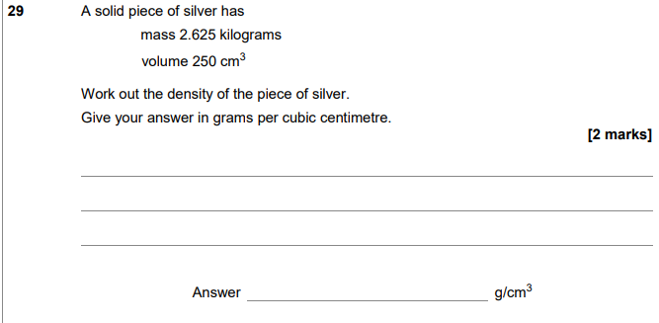
AQA Thursday 6 June 2019 – Morning (Calculator) Foundation Tier

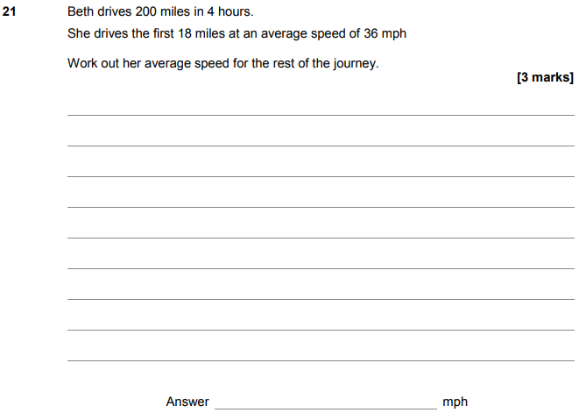

AQA Thursday 11 June 2019 – Morning (Calculator) Foundation Tier

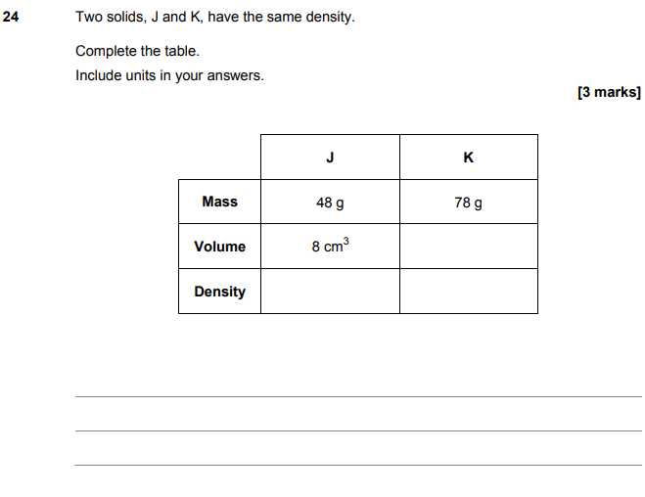

AQA Tuesday 6 November 2018 – Morning (Non-Calculator) Foundation Tier

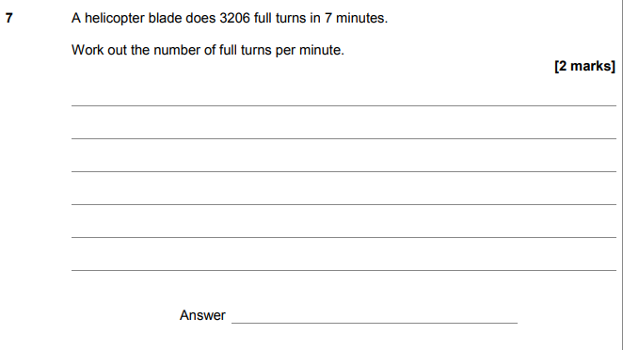
AQA Tuesday 12 June 2018 – Morning (Calculator) Foundation Tier

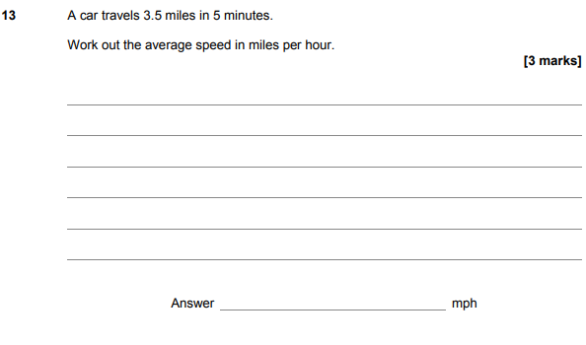

AQA Wednesday 8 November 2017 – Morning (Calculator) Foundation Tier

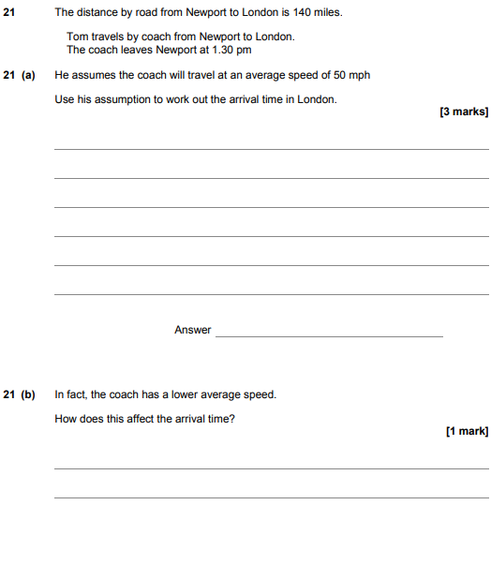

AQA Wednesday 8 November 2017 – Morning (Calculator) Foundation Tier

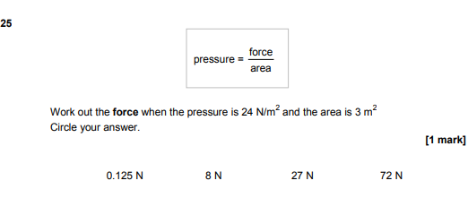

AQA Thursday 25 May 2017– Morning (Non-Calculator) Foundation Tier

